C64 WiFi-Modem for User Port Rev. 0

Module Description

This board is a WiFi modem for the User Port of the Commodore C64. It is based on the project “Build your own 9600 Baud C64 WiFi Modem For $10” of “1200BAUD” (<https://1200baud.wordpress.com/2017/03/04/build-your-own-9600-baud-c64-wifi-modem-for-20/>).

The WiFi functionality is implemented in the NODEMCU V3 development board/module, which contains an Espressive ESP8266 WiFi and RISC processor. This module can be programmed with free software via a micro USB cable.

The board contains status and activity LEDs and connects to the User Port of the Commodore C64.

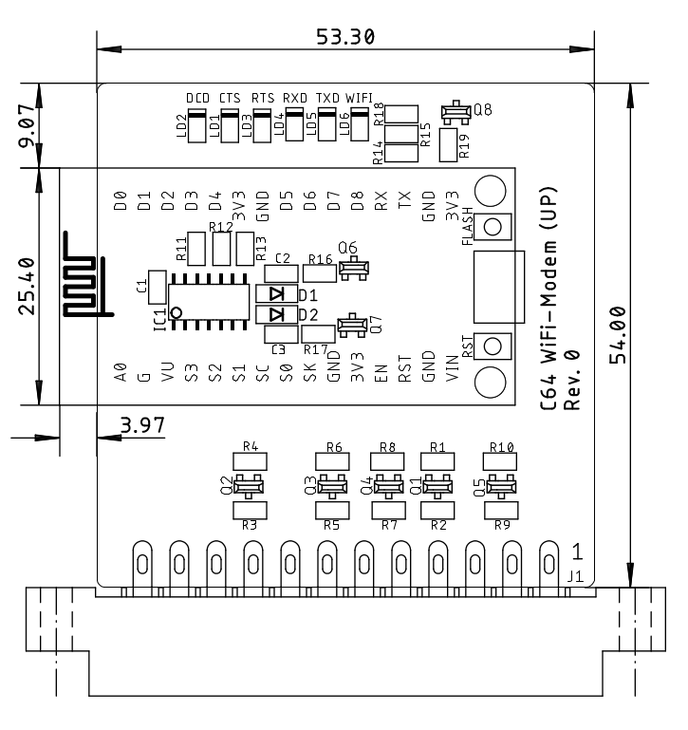

Figure 1: Dimensions of the WiFi modem board

For the NodeMCU V3 programming and the required C64 software, refer to the article mentioned above.

# Logic connections

| 3.3V level | |  | 5V level | |
| --- | --- | --- | --- | --- |
| Pin | NodeMCU V3 | Signal | User Port | Pin |
| 29 | GPIO5 (D1) | RTS | PB1 | D |
| 28 | GPIO4 (D2) | CTS | PB6 | K |
| 26 | GPIO2 (D4) | DCD | PB4 | H |
| 22 | GPIO12 (D6) | WiFi-LED* | - | - |
| 19 | RXD0 (RX) | RXD | PA2, SP1 | M, 5 |
| 18 | TXD0 (TX) | TXD | /FLAG2, PB0, SP2 | B, C, 7 |
| - | - |  | PB7, CNT2 | L, 6 |

*The function of the WiFi-LED is not implemented in the original software.